MARKETING & PHOTOGRAPHIC CONSENT FORM

PO Box 15, Officer VIC 3809 Email: secretaryofficerpc@gmail.com
Officer Pony Club 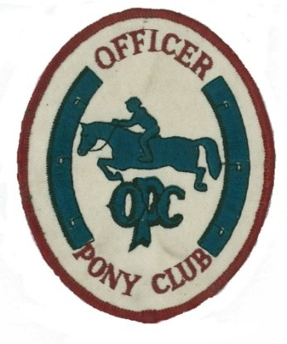
Officer Pony Club
O

Dear Parent/Guardian
At certain times throughout the year, our riders may have the opportunity to be photographed or filmed for our Clubs publications, such as the Pony Club newsletter or website and social media, or to promote the Pony Club in newspapers and other media.
We would like your permission to use your child's photograph/video for the above purposes.
This will be implemented for the duration of your child’s time at Officer Pony Club.
Please complete the permission form below and return to the Pony Club as soon as possible.
Thank you for your continued support.
…………………………………………………………………………………………………………………………………………………..
MEMBER’S FULL NAME: __________________________________________________________________________________
- I give permission for my child’s photograph/video and name to be published in:
- The Officer Pony Club’s website
- Social media
- Promotional materials
- Newspapers and other media.

- I give permission for a photograph/video of my child to be used by Officer Pony Club in the agreed publications without acknowledgment, remuneration or compensation.
- I understand and agree that if I do not wish to consent to my child's photograph/video appearing in any or all of the publications above, or if I wish to withdraw this authorisation and consent, it is my responsibility to notify the Officer Pony Club.
NAME OF PARENT: __________________________________________________________________________________
SIGNATURE OF PARENT: _______________________________________ DATE: _________________________
SIGNATURE OF RIDER : _______________________________________ DATE: _________________________

